Bangladesh Army International University of Science and Technology
Department of Computer Science and Engineering
Lab Report
Lab Report No | : | 01
Lab Report Name | : | Preprocessing Basics
Course Title | : | Machine Learning Sessional
Course Code | : | CSE 412
Name | : | Nosratee Jahan Naba
ID | : | 1118005
Level | : | 4 | Term | : I | Section | : A | Group | : 1
Date of Submission | : | 11/10/2 6 | Semester | : Fall | Year | : 2026

Question: Numpy, Pandas basics

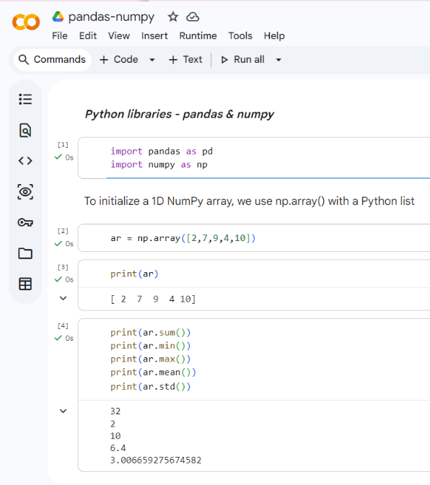
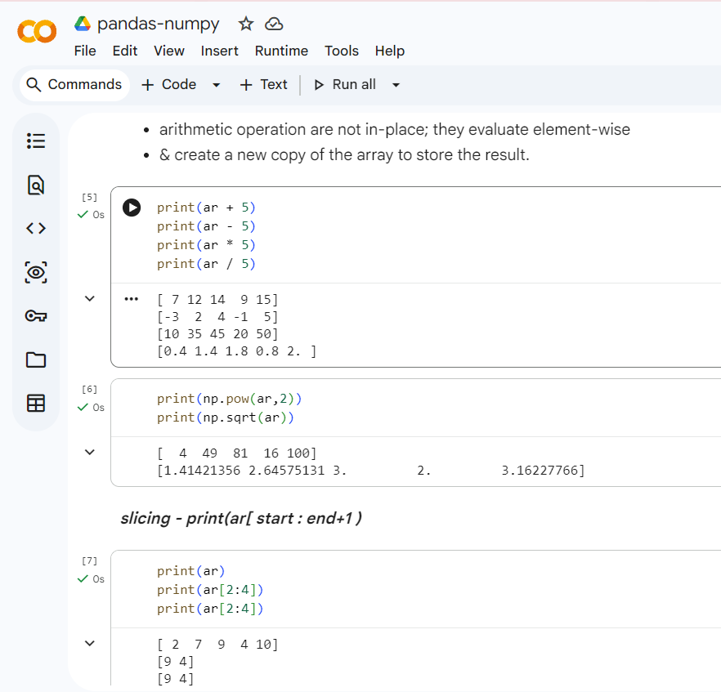
Code Implementation:

